**CONTENTS**

1. About the company
2. About the departments
3. Tasks and observations made
4. Specific outcomes

**Chapter 1**

**ABOUT THE COMPANY**

**1.1Historical Background**

**SOVEREIGN INDUSTRIES LIMITED, TERDAL** Registered as a co- operative society on 05 January 2009, under the Karnataka co-operative societies act 1959, the main purpose is to help sugarcane growers by purchasing sugar cane in the area. The manufacturing plant is located at TERDAL village, Jamakhandi Taluk, Bagalkot Dist, Karnataka.

SOVEREIGN INDUSTRIES LIMITED,TERDAL was established in January 2009 by**SHRI Ningappa Tippanna Huggi** a great visionary. This is a cooperative sugar factory and is successfully running with all environmentalmeasures in place. The plant capacity is 2500TCD. It is a standalone sugar plant with plenty of greenery with its own plantations. The estimated cost of this project is Rs. 76.10crore, is proposed to by financed by way of share capital Rs. 28.25crore and term loan Rs. 47.85crore.

During the season 2015-2016 the factory has crushed 3,37,838.402 tons of sugar cane and production 4,16,060 quintal of sugar with an average recovery 12.34% Govt. of India has fixed SMPof Rs.2200 PMT, the factory has paid Rs.2995 PMT to the sugar cane supplier.

During the season 2016-2017 the factory has crushed 1,44,092.133 tons of sugar cane and production 1,49,530 quintal of sugar with an average recovery of 10.43%. Govt. of India has fixed SMP of Rs.2600 PMT, the factory has paid Rs. 2987PMT to the sugar cane supplier.

During the season 2017-2018 the factory has crushed 270022.335 tons of sugar cane and production 306970 quintal of sugar with an average recovery 11.40%. Govt. of India has fixed SMP of Rs. 2600 PMT, the factory has paid Rs.2799.63 PMT to the sugar cane supplier.

**1.2Company’s Vision Mission and Quality policy**

**1.2.1 Vision**

SOVEREIGN INDUSTRIES LIMITED,TERDAL has dedicated to deliver overall value to their customers, delivering high quality products, exceptional financial performance to company shareholders and complete satisfaction to cane growers, employees and stakeholders.

1. Expansion of cane cultivation area.
2. Enter into joint venture.
3. To expand the group of companies.
4. Increase the production capacity to compete in market.
5. To take technology from factory to the cane fields.

**1.2.2Mission**

1. Efficiency in production.
2. To maximize creation of wealth, value and satisfaction for stakeholders.
3. Encourage the agro based industry.
4. To develop industrial movement in rural sector.

**1.2.3Quality Policy**

SOVEREIGN INDUSTRIES LIMITED,TERDALwill strive for company’s continual improvement achieving Environmental, occupational,health,and safety management system by:

1. Providing good working condition and healthier environment to all employs.
2. Optimum usage of natural resources by reducing, recycling, and re using.
3. Prevention of pollution by minimizing waste generation and proper disposal of waste generated at all activities.
4. Prevention of health and injuries by adopting safe working practices in all operations.
5. Comply with all applicable environmental requirements.

**1.3Company Profile**

**Basic Activity:**Manufacturing of sugar.

**Capacity :** 2500TCD & 6MW of Co-gen plant.

**Table 1.1 Company profile**

|  |  |
| --- | --- |
| Year of incorporation | January 2009 |
| Organization | SOVEREIGN INDUSTRIES LIMITED,TERDAL |
| Address | A/P: Terdal-587315  Tq: Jamakhandi  Dist Bagalkot, KARNATAKA |
| Manpower | 350-During season  100-During off-season |
| Total Area | 148.36 Acres |
| Built Area | Spread over an area of 7 acres |
| Green belt Area\Plantation  Area | 100 acres |
| Vacant Area | 41.36 acres |

**1.4 Sugarcane**

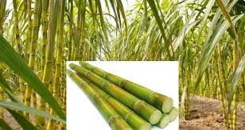

* Sugarcane is widely grown crop in India. It provides employment over a million people directly or indirectly besides contributing significantto the national exchequer.

**Climatic condition and seasons**

* Sugar cane is a long duration crop so it can be seen in all the seasons.
* In India sugarcane is planted thrice a year in October, February-March.

**Planting methods**

1. Ridge and Furrow Method - Distance 120 cm
2. Flat Bed Method - Distance 60-90 cm
3. Trench or Java Method ­­- 90-120 cm

**Steps involved in sugarcane farming**

* Sugarcane crop should be harvested at right stage of maturity because both early and delayed harvesting results in loss of quantity and quantity of the final product.
* Irrigation is withheld for about 10 to 15 days before harvesting.
* The cane is harvested by giving slanting cut at ground level by cane cutting knife.
* The cane is then stripped off dry leaves and roots.
* The immature top portion is cutoff along with 2 to 3 internodes.
* Average yield of sugarcane is 100 Tons\Ha
* It should be crushed within 24 hours after harvesting to avoid reversion of sucrose into glucose.

**1.5 Indian Sugar Industry**

Sugar industry is the second largest agro-based industry in India and contributes significantly to the socio-economic development of rural population. It supports 50 million farmers and their families and provides direct employment to over 0.5 million farmers and their families and provides direct employment to over 0.5 million skilled and semi –skilled persons in sugar mills and integrated industries. The Indian sugar industry plays a leading role in global sugar market being the world’s second largest producer after Brazil, producing nearly 15 and 25% of global sugar and sugarcane, respectively. The sugar industry which encompasses 599 operating sugar mills, 309 distilleries and 180 cogeneration plant and numerous pulp, paper and chemical making chemical making units is supported by four leading sugarcane research stations, world class sugar machinery manufacturers, suppliers and technical experts.

Currently the industry produces around 300-350 million tonnes (Mt) cane, 20-22 Mt white sugar and 6-8 Mt jaggery and khandsari to meet the domestic consumption of sweeteners.Besides about 2.7 billion liters of alcohol and 2300 MW power and many chemical are also produced. The industry is able to export around 1300MWof power to the grid. Indian sugar industry is fully capable of meeting demand of potable alcohol as well as 10% blending in gasoline. Industry is graduallytransforming into sugar complexes by producing sugar, bio-electricity, bio-ethanol, bio-manure and chemicals; these contribute about 1% to the national GDP.

**Problems of sugar industry:**

* Low yield of sugar
* Short crushing season
* Fluctuating production Trends
* Low rate of recovery
* High cost of production
* Competition with khandsari and gur

**Top largest sugarcane producing states in India in 2018**

1. Uttar Pradesh
2. Maharashtra
3. Karnataka
4. Tamilnadu
5. Bihar
6. Gujrat
7. Andra Pradesh
8. Haryana
9. Punjab
10. Utarakand

**For every 100 tons of sugar cane crushed:**

* 11 Tons of sugar
* 4 Tons of molasses
* 3 Tons of filter mud
* 0.3 Tons of furnace ash
* 30 Tons of bagasse
* 1500 KWH of Electricity

The sugarcane is being grown in many states of India like Maharashtra,Uttar Pradesh, Gujarat and Karnataka. In Karnataka the sugar cane is mostly grown around Belagavi, Bagalkot, Vijayapura, Mandya districts and coastal areas. The sugar cane can be grown in all types of soil but higher yield can be obtained in black fertile soil.

**Total India's Consumption**

India is second largest sugar producer but largest sugar consumer 190-200 Lakh metric tons per year per capital consumption of sugar by Indian population 15% per year.

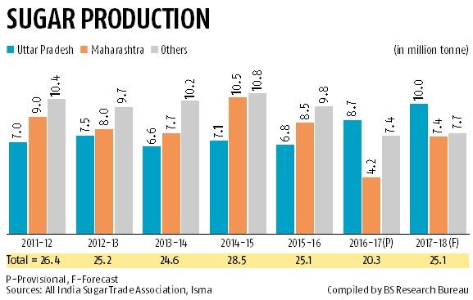

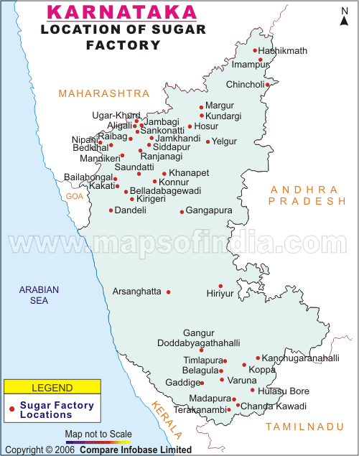**Fig 1.1 sugar cane production in india from 2011 to 2018**

**Fig 1.2 Location of sugarcane industry in karnataka**

**1.6 Organization Structure**

Chairman

Vice Chairman

Board of Director and Managing Director

Store Department

Mechanical Department

H.R Department

Purchase Department

Administrative Department

Sugarcane Department

Financial Department

Sales Department

Production Department

**Fig 1.3organization structure of SOVEREIGN INDUSTRIES LIMITED**

Organization structure gives concentrate shape to the organization. The structure specifies division of work activities and shows how different functions or activities are linked. It also indicates the organization hierarchy and authority structureand shows its reporting relationship. It provides the stability and continuity that allow the organization to survive the coming and goings of individual and to coordinate its dealing with the environment.

**1.7 Products offered by company**

**Main Products are:**

* Sugar
* Power
* Other bi- products

**1.7.1 SUGAR**

Sugar produced in**SOVEREIGN INDUSTRIES LIMITED,TERDAL**is both refined confirming to ECII grade with negligible sulphur content as well as plantation grade white sugar (Color of less than IU). Sugar is a sweet, white or brown, usually crystalline substance obtained mainly from sugar cane or sugar beets and used commonly in food products. Sugar means something sweet in the form of taste.

Formula: 12CO2 + 11H2O =C12 H22 O11 + 12 O2

Carbon dioxide + water = sucrose + oxygen

In chemistry sugar refers to any of the class of carbohydrate to which this substance belongs. Glucose, lactose, and maltose are sugar most plants manufacture. Sugar is solute in water, sweet to the taste and either directly or indirectly for maintainable.

**1.7.2 Power**

SOVEREIGN INDUSTRIES LIMITED,TERDAL has a cogeneration plant which uses steam from boiler to generate power by the bi product bagasse.

The power produced is 6MW and it is used for industrial purpose only, not sold to electrical board.

**1.7.3 Bi-products**

**Bagasse:-**

Bagasse is one of the byproduct obtained during the process. The Bagasse is produced after extracting the juice from sugar cane is used as fuel for Boilers to produce stream through which Electricity is obtained.

**Molasses:-**

Molasses is a byproduct of sugar rating chiefly used for alcohol production. The entire Molasses outcome is routed to the distillery unit.

**Press Mud:-**

Press Mud is the byproduct generated by cane juice filtration during sugar manufacture, currently press mud is used is a fertilizer in sugar cultivation.

**1.8Company Ownership Pattern**

**Authorized Share Capital**

* A-Class share: Cane growers 200 shares of rupees of face values Rs.5000.
* B-Class share: Co-operative institutions 40000 preferential shares of rupees of face values Rs.5000.
* C-Class share: Government of Karnataka 4000 shares of rupees of face value Rs. 5000.
* D-Class share: Non grower members

**Chairman**

The chairman of the factory shall have an overall control over day – today management of the factory. He shall preside over meeting of the board of directors and the general body. The chairman of the factory shall have general control over the affairs of the factory.

**Managing Director**

* Managing director shall be the officer of the factory to issue or to be issued on behalf of the

factory.

* To supervise day to day administrating of the society.
* He shall be the public Relation Officer of the factories.
* To sanction expenditure on establishment, purchase of stores and other contingent expenditure.

**Boardof Directors:**

The board of Directors shall consist of 23 Directors as under

* 17 Members to be elected by the grower members
* One member to elected by the co- operative member
* One member to be elected by non grower member
* One representative of central financial agencies
* Three nominees including Managing director of govt. will be nominated by the State Government.

**1.9 BOARD OF DIRECTORS**

**Table 1.2 Board of directors**

|  |  |  |
| --- | --- | --- |
| **SL. No** | **Name of Members** | **Designation** |
| 01 | Shri Ningappa Tippanna Huggi | Chairman |
| 02 | Shri Shivakumar Malagan | Vice Chairman |
| 03 | Shri Mallanna Gundappa Molkeri | Director |
| 04 | Shri Gurappa Reddi | Director |
| 05 | Shi Shanur Akbr Mujawar | Director |
| 06 | Shri Basavaraj Ningappa Arakeri | Director |
| 07 | Shri Prakash I. Japti | Director |
| 08 | Shri Rajashekar M. Yattinmani | Director |
| 09 | Shri Muralidhar Y. Mallur | Director |
| 10 | Shri Basanagouda V. Patil | Director |
| 11 | Shri Rachappa M. Matti (karikatti) | Director |
| 12 | Shi Mahantesh B. Doddagoudar | Director |
| 13 | Shri Mallappa G. Muragod | Director |
| 14 | Shri ShrishailappaU.Sharannapanavar | Director |
| 15 | Shri Gangappa Y. Bharamanavar | Director |
| 16 | Smt Kamala S. Awwakanavar | Director |
| 17 | SmtKasturi S. Somanatti | Director |
| 18 | Shri Mahantesh G. Ullagaddi | Director Apex Bank Rep |
| 19 | Shri UmeshS.Balli | Director |
| 20 | Shri Gangappa N. Mugabasav | Director |
| 21 | Shri Pundalik M. Mugabasav | Director |
| 22 | Shri A R Mulla | Director |
| 23 | Shri K L Shrinivasa | Managing Director |

**Chapter 2**

**ABOUT THE DEPARTMENTS**

**2.1 Different Department Heads and their Functions**

**2.1.1 Administrative Department**

**HEAD-Secretary**

**Functions:**

* To see various sections of the factory for its smooth functioning.
* To establish goals for each department.
* To take timely decision about various activities.
* To plan day to day activities and put policies in effect with the objectives.

**2.1.2 Sugarcane Department**

**Head- chief cane Development Officer**

**Functions:**

* To procure goods quality of sugar cane in proper time.
* To make arrangement to bring the sugar cane within 24 Hrs after its cutting because after 24 Hrs sucrose is converted into glucose.
* The department acts as link between farmers and factory and management so he plays a very important role for running the factory.

**2.1.3Purchase Department**

**Head-Purchase Officer**

**Functions:**

* Purchasing materials.
* Calling quotations.
* Placing orders for supply of materials.
* Passing bills to accounts section for payment.

**2.1.4Production Department**

**Head-Chief Chemist**

**Functions:**

* The Directors shall draw up a programmer of sugar cane cultivation within the area of operation and assign such cultivation to growing Members.
* Smooth production process.

**2.1.5 Human Resource Department**

**Head-Human Resource Manager**

**Functions:**

* Induction orientation.
* Training Development.
* Employee welfare activities.
* Recruitment of employees.

**2.1.6Sales Department**

**Head - Sales Manager**

**Functions:**

* Delivering sugar on time.
* Open market sales.
* Managing sale activities.

**2.1.7 Mechanical Department**

**Head-Chief Engineer**

**Functions:**

* To be preventive in maintenance.
* To check cane mill working condition.
* Controlling of technical aspects inside the plant.
* Repair and maintenance of machinery of the factory.
* To dismantle machines after season.
* After dismantling replacing the worn out materials with new one.
* Turning of bars by lathe machine.
* Drilling and tapping of the material.

**2.1.8Stores Department**

**Head - Head Store Keeper**

**Functions:**

* Storage of purchased material.
* Maintaining the inventory.
* Taking safety measures.

**2.1.9 Finance Department**

**Head– Finance Manager**

**Accounting maintained by the general office and A/c section**

* Individual ledger Account.
* Balance Sheet.
* Profit and Loss Account.
* Cash Account.

**Chapter-3**

**Tasks and observations made**

At**SOVEREIGN INDUSTRIES LIMITED,TERDAL**I have studied the different components each section and the production processing steps in each section.

**DIFFERENT SECTIONS IN SUGAR INDUSTRY**

* Feed section
* Mill house
* Boiler section
* Electrical section
* Boiling house
* Workshop section
* Store
* Sugar godwan

**3.1 FEEDSECTION**

**3.1.1WEIGHBRIDGE**

**Specifications of weighbridge:**

* Type – Electronic Weighbridge
* Weighing capacity- 40 Tons
* Load sensing element – Strain Gauge Type
* Material- Mild Steel
* Number of weighbridge-4
* It is electronically operated weighbridge and it is operated by the CQ-Multibridge software which is mainly created mainly for sugar industry
* There are four weighbridge, two are of maximum capacity 20 Tons other two are of maximum capacity of 40 Tons.
* The weighbridge is calibrated by government officers and certified licenses are given.

**Procedure carried for weighing of sugar cane**

* Each farmer is given a permit number on that number the details of farmers are stored like name, address, bank details , vehicles for transportation, details of survey e.t.c.
* When vehicle comes with load it is weighed in weighbridge and the weight is noted according to the permit number and after unloading weighed without load.
* Vehicle with load is Gross weight and vehicle without load is Tare weight and the difference between gross weight and tare weight is cane weight.
* In cane weight the binding weight is subtracted and the net weight is calculated.
* The final weight is entered under that permit number given to the farmer depending on number of trips and all weights are added and to the bank account.

**3.2MILL HOUSE**

**Components of mill house:**

* Cane Unloader
* Feeder Table
* Chopper
* Leveler
* Fibrizer
* Rake Elevator
* Mill section

**3.1.2CANE UNLOADER**

**Specifications of Cane unloader:**

* Type –Mechanical and Hydraulic type
* Motors-4 (30HP-2 , 71/2 HP-1 and 51/2HP-1)
* Gear box -4
* Drums -2
* Wire ropes -2
* Maximum capacity-7 Tons
* Number of cane unloaders- 2

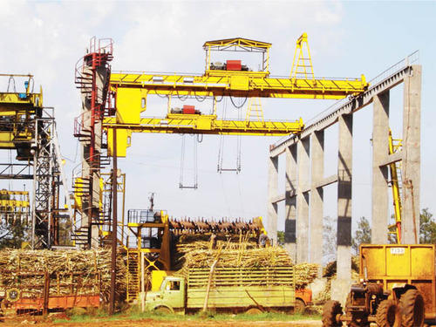  
**Fig 3.1 cane unloader**

* The cane unloader acts like a crane and these move in all four sides like front, back, left ,right.
* Cranes have sharp curved bars which are use to lift the cane and these are operated hydraulically and are moved up and down by the motors through ropes
* They are two in number ,the maximum capacity is 7 Tons
* Cane from the vehicles is lift by the cranes and unloaded at the Feeding table.
* Oil used in gear box is SERVO 320

**3.1.2 FEEDING TABLE**

**Specification of feeding table:**

* Size - 7000mm × 7000mm
* Inclination - 7°
* Number of feeder tables-2
* The purpose of feeder table is to transfer the sugarcane on the cane carrier.

**3.1.3 CANE CARRIER**

**Specifications of cane carrier:**

* Length-105 m(from drive shaft to end shaft)
* Width-1.7 m
* Height-1.01m
* Motor-60 HP(Squirrel gauge type)
* Cane carrier is a moving apron. Cane carrier is a type of conveyor belt which moved by the rollers and these rollers are rotated by the 60 HP AC motor.
* Cane carrier carries cane from feeding table to mill section and next to the boiler and next to the bagasse storage point.
* cane carrier is horizontal with vertical cane carrier

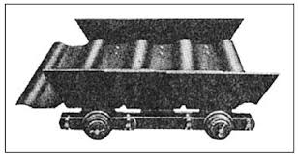

**Fig 3.2 Cane carrier**

**3.1.4CHOPPER**

**Specification of chopper:**

* Type- chopper
* Motor-120 HP (Slip ring type)
* Hubs-22
* Boards-44 (each board have 2 boards)
* Knifes-40

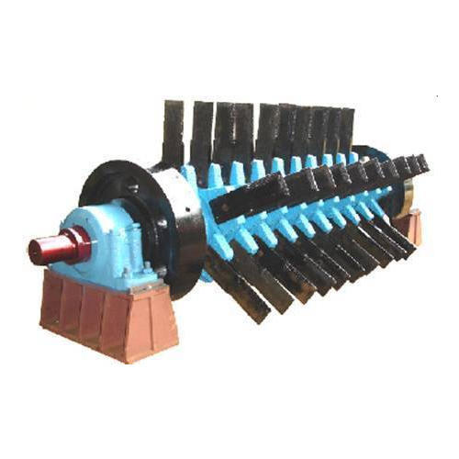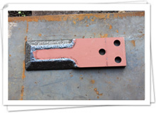

**Fig 3.3 Chopper Fig 3.4Knife of chopper**

* It is a rotating member as the name suggests it as chopper and the main function of chopper is to cut the sugarcane into small pieces.
* Cane from feeding table is first taken to the chopper through carrier.
* It consist of 22 hubs which are connected by a shaft and each hub have two boards at end and in between two boards one knife is placed which is sharpened at the ends so that cane are chopped correctly which can be seen in figure above.
* At the end of shafts flywheels are present which are rotated by the motors at each end.

**3.1.5LEVELER**

**Specifications of leveler:**

* Type - Swing type
* Motor - 275 HP (Slip ring type)
* Hubs - 22
* Boards-44( each hub have two boards)
* Knifes – 40

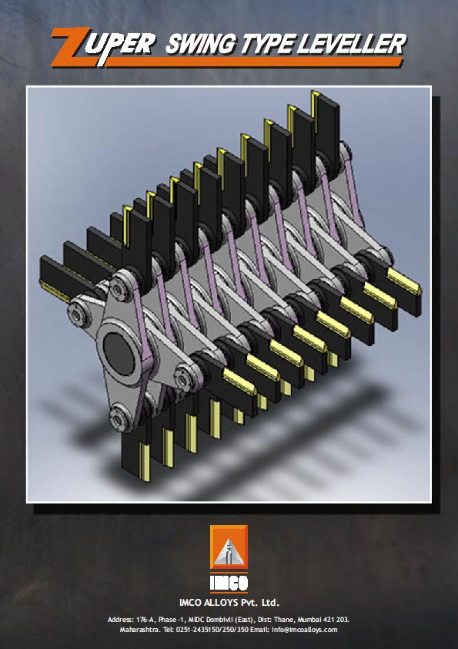

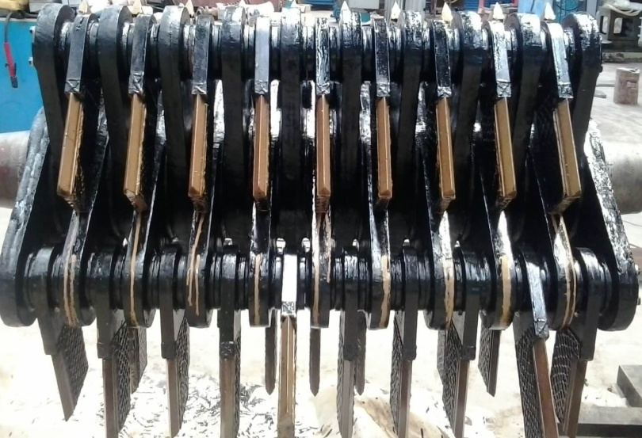**Fig 3.5swing Type Levelers**

* Leveler is the rotating part the main function of leveler is to make the canes of same level so that there should not be more load at next section.
* Chopped cane from chopper is taken to the leveler by the carrier and the canes are cut again to make the canes of same size.
* leveler have 22 hubs and each hub have 2 boards and in-between these boards knifes are present which are sharpen at the end as can be seen in figure above and the hubs are connected by a shaft which has flywheel at the ends and the flywheels are rotated by the motors.

**3.1.6 FIBRIZER**

**Specifications of fibrizer:**

* Type – Swing type fibrizer
* Motor – 500 HP (slip ring type )
* Hubs – 24
* Boards- 96 (each board have 4 boards)
* Hammers – 88

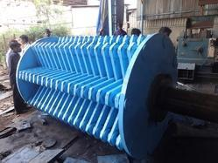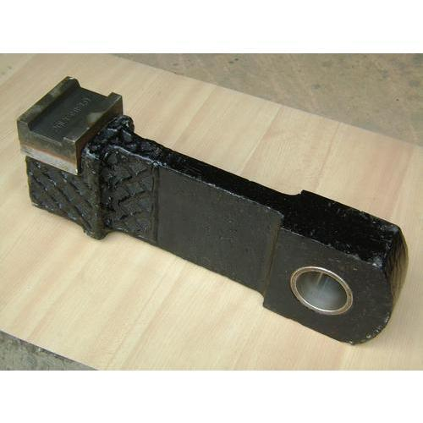

**Fig 3.6 Fibrizer** **Fig 3.7 Hammer of fibrizer**

* Fibrizer is a rotating part which is swing type and its main function is to make the cane in the form of powder so that heavy load is not required at milling part.
* Cane from leveler is fed to the fibrizer by the cane carrier.
* Fibrizer consist of 24 hubs and each hub consist of 4 boards, in between these boards hammers are present which are 88 in number and they have cutting tips at the ends which is used to make cane in the form of powder those cutting tips can be seen in the figure above.
* Hubs are joined together by the shaft at the center, shaft have flywheels at each end these flywheels are rotated by the motors which are of high power.
* Fibrizer at outside is cooled by water jacket and inside is cooled by bearing grease.
* Oil used in fibrizer is S.S.100 and grease is SERVO.GEM .3

**3.1.7 Rake elevator**

**Specifications of rake elevator:**

* Size - 2.1m width × 1m depth
* Length - 8m

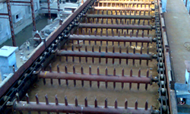

**Fig 3.8 Elevator for carrying shrededed cane**

**3.1.8Mill Section**

**Specification of mills:**

* Mills- 4
* Rollers-16 (Each mills have 4 rollers)
* Motor- 1000 HP (DC motor )
* Drive gear -38 teethes
* Master gear-130 teethes
* Number of inter carrier -3

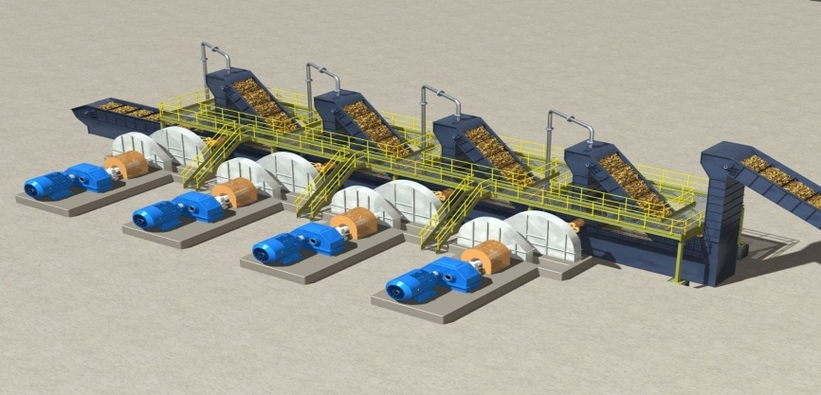

**Fig 3.9 mills arrangement**

**Mill arrangement:**

* There are mainly four mills and these are numbered 1, 2, 3&4.
* There are inter carrier in between mills which carry crushed cane to next mill these are of rake elevator type carriers which are 3 in number.
* Each mill have a 1000 HP DC motor rotates the drive gear which has 38 teeth then drives master gear which has 130 teeth rotates the coupling in turn to rotate the pinion of roller .

**There are four roller mills:**

1. **Underfeed roller**
2. **Feed roller**
3. **Top roller**
4. **Discharge roller**

**Roller arrangement**

**TOP ROLLER**

**ROLLER**

**DISCHARGE**

**ROLLER**

**UNDERFEED ROLLER**

**FEED ROLLER**

**Fig 3.10 Roller Arangement**

|  |
| --- |
| **C:\Users\dell\Desktop\download (2).jpg**  **Fig 3.11 Under feed roller** |

|  |
| --- |
| **C:\Users\dell\Desktop\sugar-mill-roller-500x500.jpg**  **Fig 3.12 Top, Feed, discharge Roller** |

**Specifications of roller mills:**

* Pitch – 50 mm( 1st and 2nd mill) ,

35mm (3rd mill)&

30 mm (4thmill)

* Journal size – 545 mm x 420 mm
* Gear ratio – 64:1
* Roller size – 36” x 66”
* Roller speed- 4.63 rpm

**3.3 BOILER SECTION**

Boiler is a device used to create steam by applying heat energy to water, boiler incorporates a furnace in order to burn fuel and generate heat. The generated heat is transferred to water to make steam, the steam produced is super heated steam which can be used immediately to produce power via turbine and alternator.

**Specification of boiler:**

* Make- Tyssen Krrup
* Type – water tube boiler
* Number of boilers-2
* Capacity-40 Tons\hr( Each boiler capacity)
* Super heated steam temp – 4400c
* Steam pressure- 45 kg\cm2
* Furnace type- Dumping rate type
* Chimney height-60 m
* Number of water tubes-864 (18rows x 48tubes)

**Water Tube Boiler:**

In water tube Boiler a number of water tubes are arranged in and around the furnace. Water circulates in the tubes and outside is the fire. This type generally gives high steam production rates, but less storage capacity. Water tube boilers are also capable of high efficiencies and can generate saturated or superheated steam.

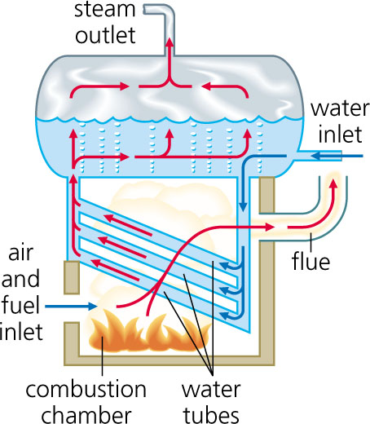

**Fig 3.13Water tube boiler**

**Types of fan used in boilers:**

* ID Fan ( Induced draught fan)
* FD Fan (Forced drought fan)
* SA Fan (Secondary fan)

### ID Fan (Induced Draught Fan):

Induced draught fan draw gases out of the boiler. It is located in-betweenwet scrubber and chimney, it takes hot flue gases from furnace via wet scrubber and will deliver to chimney. ID fan will produce the pressure lower than the atmospheric pressure in the system, flue gasses are passed through air heater and wetscrubber before going to the chimney.

**Specifications of ID fan:**

* Fan speed - 750 rpm
* Static Pressure –325 mm wg
* Motor- 180 HP

### FD Fan (Forced Draught Fan):

It takes air from atmosphere and passes it through the air pre-heater tubes, which is then blown into the furnace from its base through dumping gate. This warm air helps in smooth combustion and spreading bagasse. Each unit has forced draught fan. The fan draws warm air from the top of the boiler house through large air heaters becoming the primary and secondary air used for the boiler combustion process. The air heater warms the incoming air by transferring heat energy from the outgoing flue gases.

**Specification of FD fan:**

* Fan speed – 1440rpm
* Pressure – 225 mm wg
* Motor – 120 HP

**3.4 DM PLANT**

**Water filtration process flow**

**Raw water**

**Filter water storage tank**

**Dual media filter(DMF)- 1ST Tank(Mud stone filter)**

**Activated carbon filter- 2nd Tank (Carbon filter)**

**Strong acid cation-3rd Tank**

**Degasser tower (DG) (Air removal)**

**Weak base anion (WBA)**

**Strong base anion (SBA)**

**Mix bed (MB) (7.2-7.5 PH)**

**DM storage tank**

**3.5Cogeneration section**

In co-gen section steam produced by the boiler to generate electric power. First heat energy of steam is converted in mechanical energy by turbines and then mechanical energy is converted into electrical energy by the help of generators.

In this factory back pressure turbines are used and the capacity is 6MW which is used only for factory purpose.

**TURBINE**

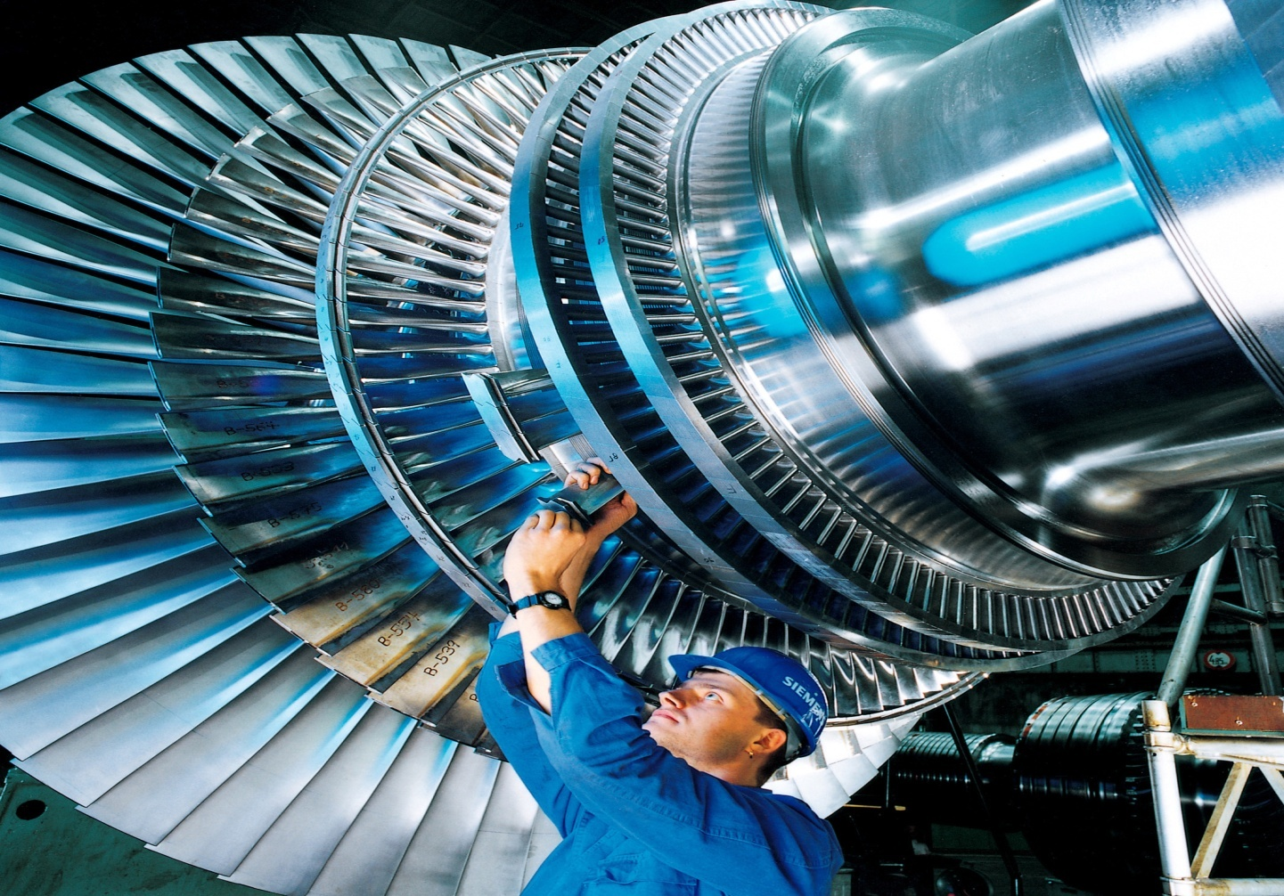

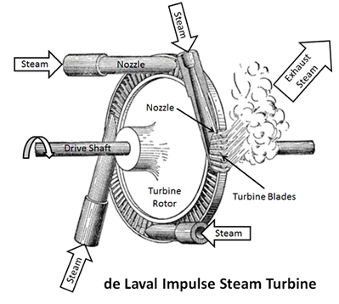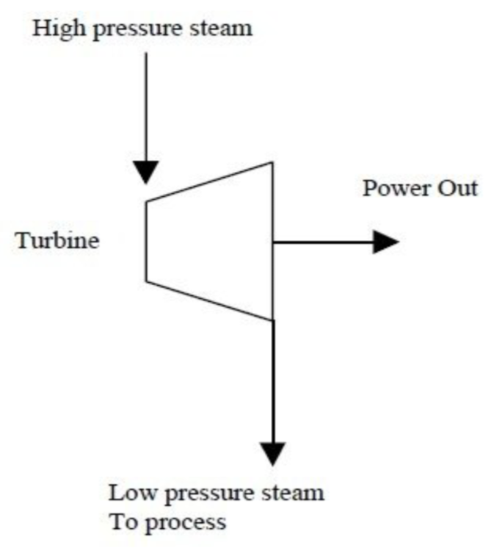

**Fig 3.14 Back pressure turbine Fig 3.15 Impulse turbine**

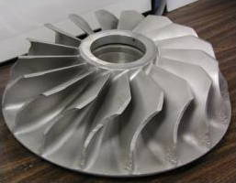

**Fig 3.16 Reaction turbine**

**Back pressure turbine (Non-condensing steam turbine):**

It is a type of steam turbine that is used in connection with industrial process where there is need of low or medium pressure steam.Backpressure means that the steam at exhaust of these turbines is having steam of pressure above than atmospheric pressure.This exhaust steam is not condensed so that it can be used at boiling house. The exhaust pressure is controlled by a regulating valve to suit the needs of the process steam pressure.

## 3.6BOILING HOUSE

**Components of boiling house**

* **Clarifiers**
* **Evaporators**
* **Pan section**
* **Centrifugal section**

**Properties of sugar cane juice:**

* Temp -320c
* PH- 5.4
* Greenish colour
* Soluble impurities

* Insoluble impurities like proteins, waxes, gums etc.
* Physical and chemical processes are required for the production of sugar. These operations carried out in process house.

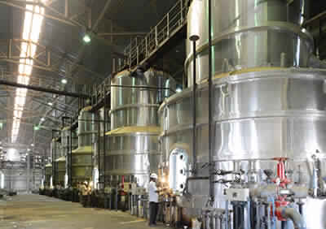

**Fig 3.17 Boiling House**

**Flowchart showing process parameters**

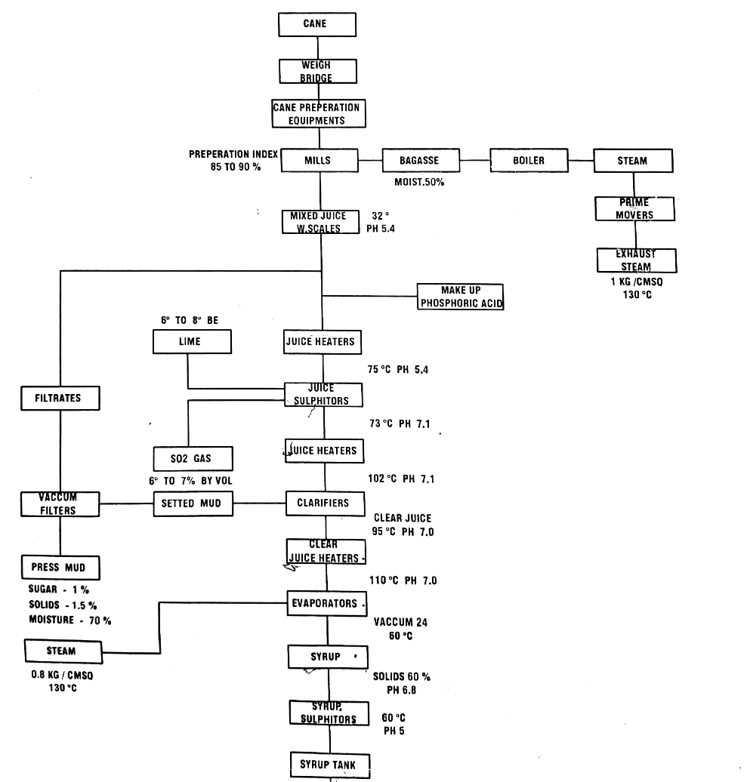

**Fig 3.18 flow chart of process with parameters**

**Flow meter:**

Juice from the mill section is taken to the boiling house where there is presence of flow meter which the amount of juice flowing to the boiling house from mill section.

**Juice heaters:**

Juice coming from mill section have a trmperature of 320c and PH 5.4 is first taken to the juice heaters of shell and tube heat exchanger and these juice heaters are five in number where juice is heated to a temperature of 750c and have PH 5.4 . Juice is heated because the chemical reactions at further stage should take place correctly.

**Juice sulphitors:**

Juice from juice heaters is taken to the juice sulphitors where lime and sulphur gas are added to remove the non sugar &maintain PH 7.0-7.1, SO2 gas will be 6 to 7% by volume of juice .

Juice is heated again before sending to clarifiers , it is heated upto 1020c and have PH 7.9 .

**Clarifiers:**

A clarifier is used to separate out the solids suspended in the cane juice.These solids originate from sand adhering to the cane stalksas well as from material inherent in the cane stalk. The separation takes place by allowing the solid particles to settle onto a tray .The solids are swept from the tray into a mud compartment .

The clarified juice is the clear juice which is having temperature 950c with PH 7.0.

**Specifications of clarifier:**

* Capacity- 4100 HL
* Height – 20 feet
* Diameter- 30 feet

**Mud Boot:**

Impurities which are settle down in clarifier are collected in tanks known as mud boot placed at bottom of clarifier.

**Mud Mixer:**

Mud from clarifier goes to into the mud mixer. The main purpose of mud mixer is to form thick(viscous) mud , by adding milk of lime, polyelectrolyte.

**Vaccum filter:**

Mixture of mud and bagasse is brought to vaccum filter, the main function of vaccum filter is to remove sweetness from the mud.

* Vaccum filter consist of drums which rotates at a speed of 0.3 rpm means it rotates slowly for

good filteration.

* When drum rotates mud becomes attached with walls and at same time mud is treeated with hot water from top.
* The filterate area is 58 m2.
* The press mud consist of
* Sugar -1%
* Solids-1.5%
* Moisture-70%

**3.6.1 EVAPORATORS:**

An evaporator is equipment that is used to concentrate the solution by evaporating the solvent(water).

**Falling film type evaporator:**

The type of evaporator used is long tube or **fallingfilmtype evaporators**.Working of this type of evaporators is solution enters the lower tube sheet and flows up inside the tubes,steam on the outside of tubes cause evaporation of solution so that evaporated gas moves upward and the remaining solution will fall downwards by gravity as a continuous film . The solution will create a film along the tube walls progressing downwards(falling) hence the name is falling film evaporator. These are mainly two in number which are connected in series.

**Vacuum-boiling ceels or bodies:**

To concentrate this clarified juice about two-thirds of the water is removed through vacuum evaporation. It is the process of causing the pressure in a liquid filled container to be reduced below the vapourpressure of the liquid,causing liquid to evaporate at lower temperature than normal, mainly three vacuum-boiling cells 0r bodies are arranged in series so that each succeeding body has higher vacuum(low pressure therefore boils at lower temperature).The vapors from one body can thus boil the juice in the next one the steam introduced into the first cell does what is called multi-effect evaporation. The syrup from the last evaporator goes to the syrup tank for crystallization process.

**1st evaporator specification:**

* Type – Falling film type
* Hitting surface -1800 m2
* Number of tubes - 1647 tubes(vertical tubes)
* Dimension of tube - Length – 8 m

-Inner diameter – 42 mm

- Outer diameter – 45 mm

**2nd evaporator specification:**

* Type – Falling film type
* Hitting surface – 1600 m2
* Number of tubes - 1447 tubes(vertical tubes)
* Dimension of tube - Length – 8 m

- Inner diameter- 42 mm

- Outer diameter – 45mm

**3rd evaporator specification:**

* Type – Vacuum boiling cell or body
* Hitting surface - 600 m2
* Number of tubes - 2626 tubes(vertical tubes)
* Dimension of tube - Length – 2 m

- Inner diameter- 42 mm

- Outer diameter – 45mm

* Juice temp 950c

**4th evaporator specification:**

* Type – Vacuum boiling cell or body
* Hitting surface - 350 m2
* Number of tubes - 1314 tubes(vertical tubes)
* Dimension of tube - Length – 2 m

- Inner diameter- 42 mm

- Outer diameter – 45mm

* Juice temp 700c

**5th evaporator specification:**

* Type – Vacuum boiling cell or body
* Hitting surface - 350 m2
* Number of tubes - 1315 tubes(vertical tubes)
* Dimension of tube - Length – 2 m

- Inner diameter- 42 mm

- Outer diameter – 45mm

* Juice temp 600c

**Flow chart showing process parameters in pan and centrifugal section.**

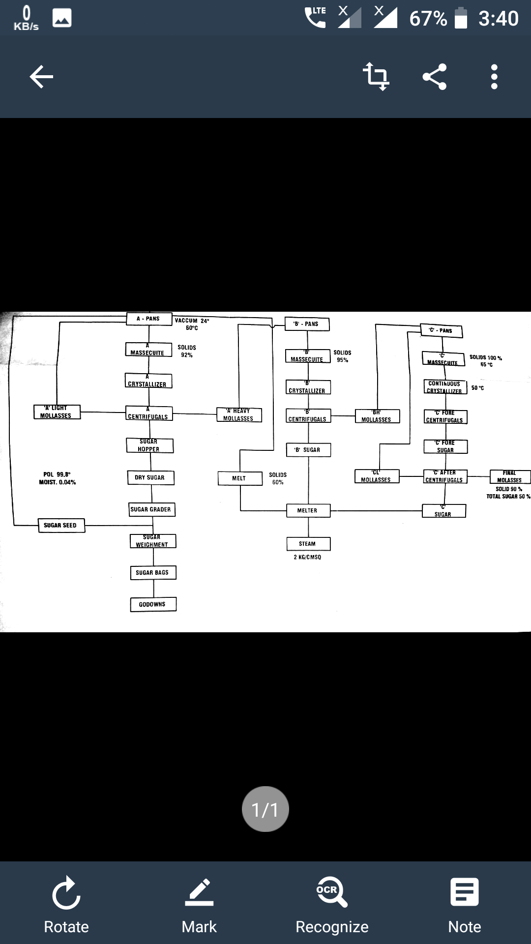

**Fig 3.19 Flow chart of parameters in crystallization process**

**3.6.2CRYSTALLIZATION:**

Crystallization is the next step in manufacture of sugar. Crystallization is a process of formation of sugar crystals from syrup with the help of vacuum pans.

Syrup from evaporators is pumped to a vacuum pan in which it is evaporated to saturation until saturated with sugar. As soon as the saturation point has been exceeded, small grains of brown sugar (size 60-70 microns) are added to the pan from slurry tank. These small grains called seed,serve as nuclei for the formation of sugar crystals.Addition syrup is added to the strike and evaporated so that the original crystals are allowed to grow in size.

The growth of the crystals continues until the pan is full. When sucrose concentration reaches to desired level, the dense mixture of syrup and sugar crystals called are discharged into large containers known as crystallizers.

Vacuum pans are specified for different boiling of different massecuite and seeds.

Massecuite = molasses + crystals.

**3.6.3CENTRIFUGE:**

The high speed centrifuge action used to separate the massecuite into raw sugar crystals and molasses is done in revolving machines called centrifuge. A centrifuge machine has a cylindrical basket suspended on a spindle, this cylindrical basket is having monitor case on outside then bearing housing is placed in it with screen or mesh which are having 400 to 600 perforations per square inch. The basket revolves at a speed from 1100 to 2000 RPM. The raw sugar is retained in the centrifuge basket because the perforated lining retains the sugar crystals. Molasses is passes through the lining because of centrifugal force.

**A pan & A centrifuge:**

* A pan consist of 3 pans arranged continuously one after the other.

**Specification of 1st pan:**

* Capacity - 80 Tons
* Heating surface -430 m2
* Number of tubes – 1519 tubes
* Tube length - 900 mm
* Inner diameter – 98 mm
* Outer diameter – 102 mm
* The crystallizer used is having capacity of 80 Tons and it has fine edge curves bars to rotate the mixture which is by the use of finetary gears.

**Specification of 2nd pan:**

* Capacity - 80 Tons
* Heating surface -430 m2
* Number of tubes – 1519 tubes
* Tube length - 900 mm
* Inner diameter – 98 mm
* Outer diameter – 102 mm
* The crystallizer used is having capacity of 80 Tons and it has fine edge curves bars to rotate the mixture which is by the use of finetary gears.

**Specification of 3rdpan:**

* Capacity - 60 Tons
* Heating surface - 303 m2
* Number of tubes - 1204 tubes
* Tube length - 800 mm
* Inner diameter – 98 mm
* Outer diameter – 102 mm
* The crystallizer used is having capacity of 60 Tons and it has fine edge curves bars to rotate the mixture which is by the use of finetary gears.

**Specification of A centrifuge:**

* Number of centrifuge machine – 4
* Capacity – 1100 kg
* Speed of centrifuge – 2000 RPM
* Size of mesh - 0.1

Syrup from syrup storage tank is taken into A pan along with syrup Melt, A heavy and melt are added . Vacuum boiling is done at 60°C, then A massecuite is formed.

**B pan & B centrifuge:**

**Specification of 4th pan:**

* Capacity - 60Tons
* Heating surface -303 m2
* Number of tubes – 1204 tubes
* Tube length - 800 mm
* Inner diameter – 98 mm
* Outer diameter – 102 mm

**3.8 SWOT AYNALSIS:**

SWOT analysis means Strengths, Weakness, Opportunities and Threats. Strengths are internal, positive characteristic that the company possesses. One should look at competitive advantage. Weaknesses are internal as well as negative aspect of the company and indicate competitive vulnerabilities. These should be distinguished from problem in that immediate collapse is not likely. Opportunities are external and provide area of growth or improvement of the company. Threats are external to the company and action is required.

**STRENGTHS:**

* Co-generation scheme now factory have 2500TCD crushing capacity.
* Availability of high recovery and yield of sugarcane.
* Basic industry to agriculture.
* Good source of raw material.
* Well defined infrastructure for better market connectivity.
* Employment to the people in this area.
* It has good reputation in sugar market.
* High production efficiency.
* Good relationship with farmers.

**WEAKNESS:**

* Should use the modern equipments.
* Lower compensation for employees compared to other organization.
* High cost of production.
* No control on minimization the losses during the process.
* Lack of research and development.
* Seasonal production.
* Weaker in developing the industry.
* Focus on different department is less.

**OPPORTUNITIES:**

* High investment is needed.
* Scope to improve the profitability.
* International markets can be tapped.
* Government Issue certificate to make loan.
* Scope to setup the green field project.
* It can start its own paper mill by using baggage in future after improvement of financial position.
* Industry can havedistillery unit.
* Now the world is moving towards automation so care should be taken to improve company to have competition with other companies.

**Chapter 4**

**Specific outcomes**

**4.1 Experience &Assessment**

Experience is the most important part of doing work in any field because by experience we come to know how things are going to work from smaller to bigger level.

Internship will provide work experience to the students which is the most important aspect while hiring the employees. To get a job we must have experience so internship are best way of getting the experience.

* **Work experience**

In internship we get to know how things works in a specific field, as students we will be not having practical knowledge of how the industry works so internship will give us the practical knowledge so we get to know many things.

* **To set a Right carrier**

By having internship we will get to know in which part we are interested and have more curious to learn it. So on this we can set our carrier which is right path for us in future and we can work on in detail and become expert on it which is the important aspect seen while hiring the employees.

* **Transition into a job**

After finishing the internship the students can become a full time worker in the industry if student is interested.

* **Apply our knowledge**

Internship is doing the practical things so we can apply our knowledge on those things and get to know it in detail. This will improve in understanding our class knowledge in a better way and improve the practical knowledge.

**4.2Technical outcomes**

* Gained knowledge of how sugar industry uses engineering aspects to produce sugar.
* Get to know how the sections work by the use of machines, mechanical parts.
* Components used in each process.
* Arrangement of different sections according to their process.
* Study the processing of sugar.
* Apply the knowledge learned in class room.
* Get to know how the things work practically.
* How to handle big parts with care.
* What must be the knowledge we must have so that we can work in this type of industry.

**4.3 Non-Technical outcomes**

* **Time management**

Time management is the most important thing in life it improves the disciplineand there is saying that time is money , once the time goes never comes back.

From time management we get to know how the specific tasks are completed, reaching the industry at correct time is important and taking the information at correct time and doing the report work within time and doing scheduling for going to different sections by this we can get to know the value of time.

* **Communication skills**

As communication is important part of our life it delivers our message to others, as good our communication skills are, there is good interaction and better understanding so they can response easily.

In industry we find many people who are with different designation so how to talk with secretary, HR, MD should be known like explaining our requirements and our views and with engineers gaining knowledge from them and from the fitters to collect information while marketing any product we must communicate in the way that they must believe us and have good way of communication between us and customers. So important thing in communication is respecting others.